**Day 3 - 23rd May 2025**

Task 1:

What are the Advantages of Cloud?

9.44 to 9.49 to 9.51

5 min

Plz ensure:

Jenkins intsall —- Done

Tomcat setup — Done

Git setup — Done

Maven Setup — Done

Configuration –Done - JENKINS_HOME" environment variable

Management –Done

Setup Build Jobs — Done

Install jdk 8 or JDK 17- pre requisite for jenkins

Docs batch 2 link - day wise

<https://drive.google.com/drive/folders/1p0nar8-8UL70uPgB_DJFBTT503BaYzr5?usp=sharing>

Docs to study

<https://drive.google.com/drive/folders/1vsL_jdQIsTMz92S9s5LDqMrYeDuuwIfx?usp=sharing>

MongoDB

MongoDb Installation link

<https://www.mongodb.com/try/download/community>

MongoDb installation steps link

<https://www.mongodb.com/docs/manual/tutorial/install-mongodb-on-windows/>

this is also MongoDb link any one you can follow..

<https://www.geeksforgeeks.org/how-to-install-mongodb-on-windows/>

Mongosh installation steps link

<https://www.mongodb.com/docs/mongodb-shell/install/>

Setting the path..

Env path

C:\Program Files\MongoDB\Server\7.0\bin

C:\Program Files\MongoDB\mongosh\mongosh-2.2.12-win32-x64\bin

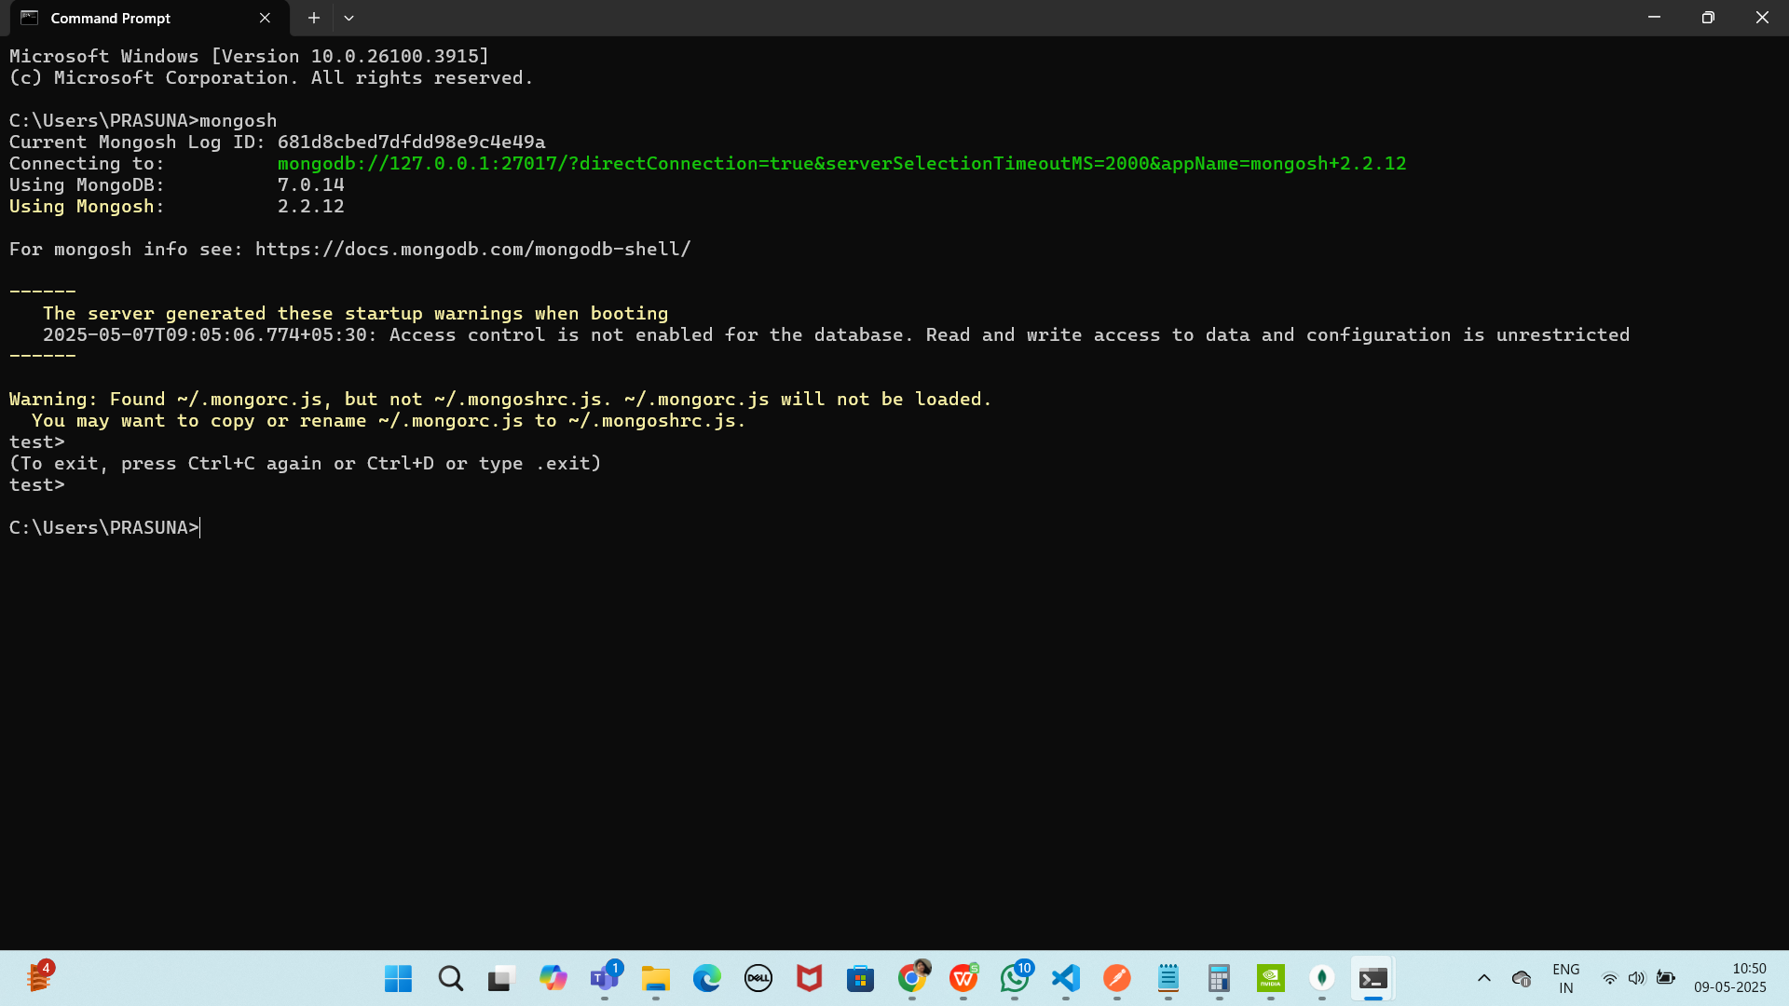

mongo db compass

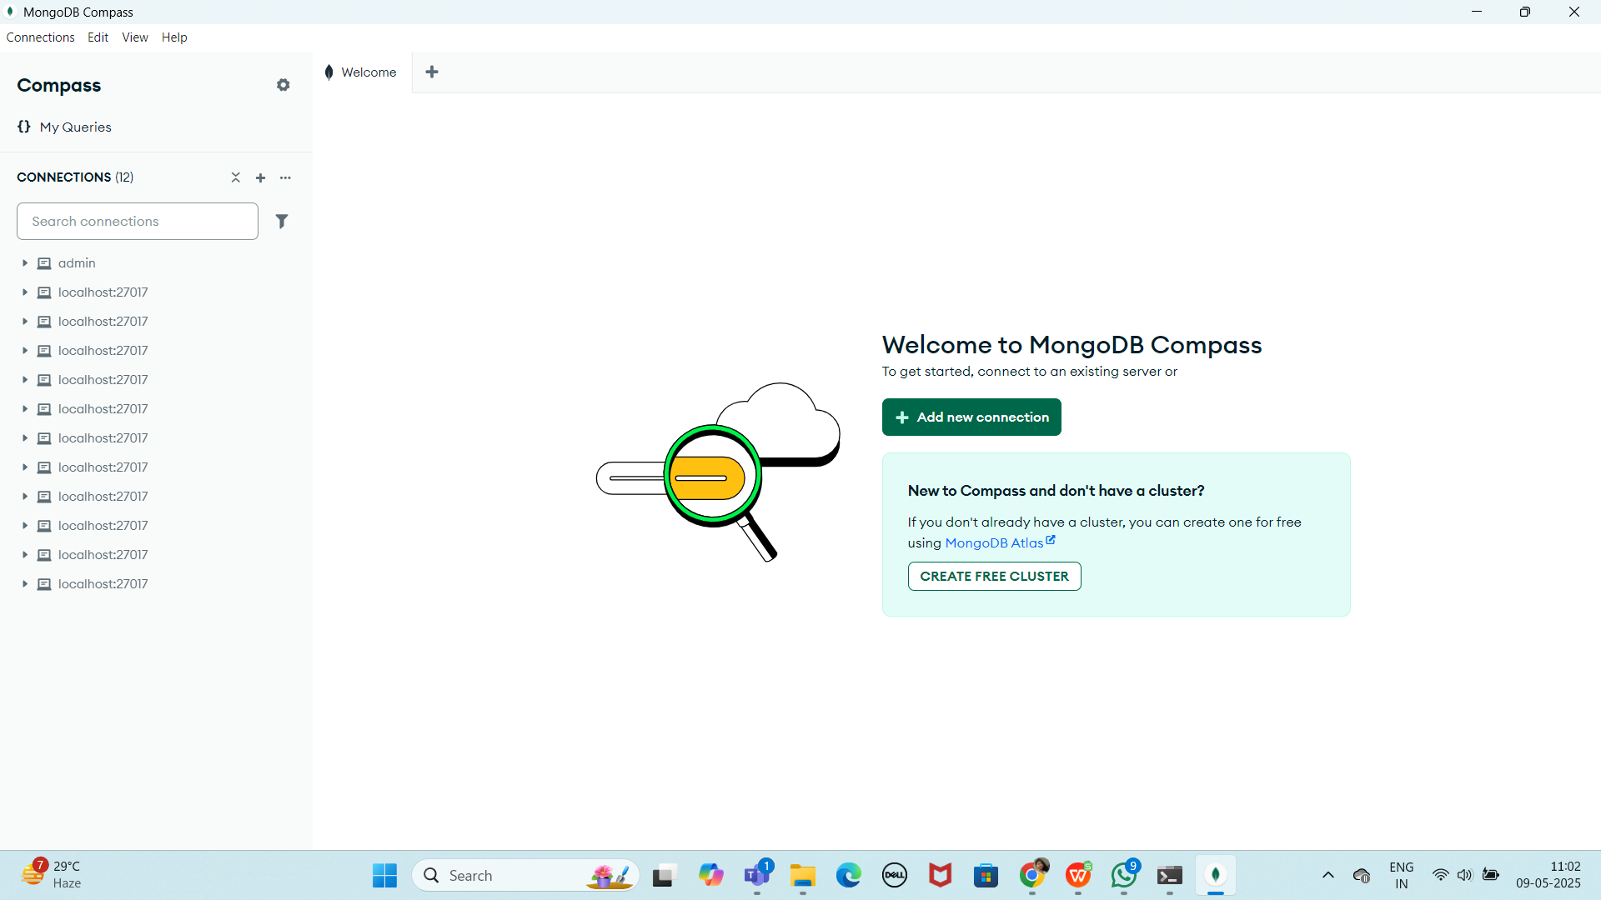

Make sure 2 cmd s are open

1. Cmd - mongod
2. Cmd - mongosh